Date:
Living Together Agreement
☐ Explain what a Housing Agreement is and why it is important
- Similar to a Boarding or Lodging Agreement but focused on supporting living arrangements that are more like a family home.
- Sets out the rights and responsibilities of the living arrangement, and any house rules that may be in place.
- Important to be clear about what is expected of each other and how everyone will overcome issues before they arise
☐ Use the ‘Setting Up a Housing Agreement Discussion Guide’ to fill out this agreement
☐ Once completed, attach the agreement to the Housing Allowance Application Form

What is working well?
Discuss what is going well in the current arrangement, this can be done separately or as a group using the Discussion Guide for different topic areas.

What are the things that we would like to discuss?
Discuss what is important to the young person and others in the living arrangement and what could become an issue. You can use the Discussion Guide to come up with a list of topics to discuss. Write down the key issues for discussion that came up.
Young Person

Landlord/Family

What are our plans to make it work?
Discuss each topic area that came up and what are your plans are to make it work. This may include a list of who is responsible for what or going through each topic area. Note here the non-negotiables, key house rules and expectations on the young person.
Young Person

Landlord/Family

Finances – It can be difficult to talk about money, but to be eligible for a Housing Allowance, a young person must contribute to costs. How much does it cost for the young person to live in the arrangement? What costs and bills are included?
Explore things like food, and transport, and contributing and being part of family activities. What costs are not included?
How much will the young person pay? When will they pay?

How long will this arrangement be for? What happens if the young person wants to leave, or can’t continue to stay here for other reasons?
How much notice will be needed from the young person? How much notice will be needed from the Landlord/Head Tenant. If the young person leaves, will others still be able to maintain the Housing?
What do we do if we have any issues?
Discuss what each party is going to do: if they are not happy with the agreement; someone is not meeting their side of the agreement; and if there are any issues. This may need a discussion with other household members.
How do we end the agreement?
List what the young person and carer or family members agree to should one person want to end the agreement; include how much notice is needed.

Roles & Responsibilities

Landlord/Family
- Provide a safe and stable living arrangement for the agreed period of time, and for the costs agreed.
- Support and encourage the young person with their transition to independence
- Discuss any issues or concerns directly and respectfully with the young person
- Review the agreement with the young person if it needs to be amended
- Contact Home Stretch WA to discuss any living arrangement issues or concerns
- Participate in living arrangement reviews with Home Stretch WA
- Notify Home Stretch WA as soon as the young person leaves the living arrangement,
to avoid liability for overpayment
Young Person
- Meet with the Home Stretch WA Transition Coach as agreed, to work towards
agreed goals and transition to independence
- Contribute to costs of the living arrangement as agreed.
- Discuss any living arrangement issues or concerns with the landlord/family.
- Contact Home Stretch WA to discuss any living arrangement issues or concerns
- Participate in living arrangement reviews with Home Stretch WA
- Notify Home Stretch WA if no longer in the living arrangement
Home Stretch WA Transition Coach
- Support the young person to explore their goals and aspirations, develop a housing pathway plan and assist with transition to independence
- Support the young person to create an agreement with the landlord/family.
- Support the young person to keep their side of the agreement, and deal with any challenges that arise.
Optional - Home Stretch WA Staying On Facilitator
- Support the landlord/family to develop the Agreement,and understand their responsibilities.
- Support the landlord/family with the living arrangement including access to resources and specialised supports
- Facilitate and organise reviews of the Agreement as required

Department of Communities
- Payment of the Housing Allowance through the Department of Communities Subsidy Processing Unit

We (young adult’s name) and (carer/s or family member) agree to continue the ‘Living Together Agreement’.
Agreement

- We understand the living arrangement is voluntary and until the young adult turns 21
- We agree to respect each other and follow any agreed ‘house rules’
- We are going to review the Agreement should things change and if any
areas need to be amended
- The Agreement is going to be reviewed on (4 weeks from agreement date), then reviewed every 3 months or as agreed
- We agree to an annual review of the Agreement
- We agree to give the each other weeks' notice to end the Agreement
- We agree to contact Home Stretch WA and the Department of Communities if this agreement is not working and/or the young person moves out of the living arrangement
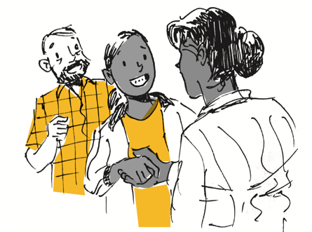

Young Adult & Carer/s Signatures | Date
Name:
Signature:
Name:
Signature:
Name:
Signature:

Actions for follow up | Who | Date

