Staying On – Combined Review and
Subsidy Application Form
Name: |  |  | Review Date:
☐ Year 2 | ☐ Year 3 | ☐ Other:
What has worked well over the length of the Staying On Agreement?
What are the good things that have happened as a result of Staying On?
What have been the challenges to living together? Are there any barriers to overcome?
Finances - How has the young person contributed to expenses? Is the young person ready to increase their contribution for the next Staying On Agreement period?
Has the young person completed a budget?

How much more can the young person contribute to the next agreement?

How much is the Staying On Subsidy?

The subsidy is staged down every year and formally reviewed every 12 months
(Refer to the Staying On guide for young people and carers for subsidy amounts)
- As per the Staying On Agreement principles, the young person is encouraged to contribute more to the household each year as a result of the subsidy decrease, to help the young person prepare for the costs of independent living.
- The young person should have their own independent income to contribute to household costs (board, bills, food etc.)
The Transition Coach can have a conversation with the young person to help this happen.
A budget and housing pathway plan can be completed prior to each 12 month review.

What is the housing pathway plan? How does Staying On in this arrangement help
achieve that?
Actions/Notes
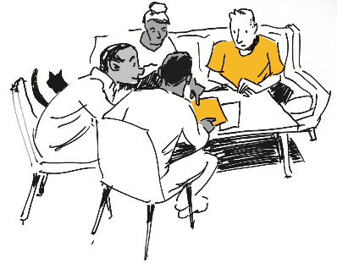

Young Adult & Carer/s Signatures | Date
Name:
Signature:
Name:
Signature:
Name:
Signature:

Subsidy Agreement
I/we declare the following:
I/we understand the conditions of maintaining payment of the Staying On Subsidy and agree to participate in review meetings with the Home Stretch WA provider.
I/we will notify the Department of Communities through the Home Stretch WA Provider as soon as the young person leaves the care arrangement to avoid overpayment.
I/we understand and agree to repay any overpayments made because of not advising the Home Stretch WA Provider and/or Department of Communities of changes that may affect the payment and/or not complying with requirements of the Staying On arrangements.
I/we understand that the Staying On arrangement is voluntary and I/we can end the arrangement at any time by notifying the Home Stretch WA Provider and the Department of Communities
I/we understand that the Staying On arrangement must be a choice made by the young person we are supporting, and they can end the arrangement at any time by notifying the Home Stretch WA Provider and the Department of Communities

Carer 1: _______________________________ Signature: ___________________
(Name)
Carer 2: _______________________________ Signature: ___________________
(Name)

Fortnightly subsidy amount ($) to be paid
Date This Agreement Commences
Date Agreement Ends (12-month max)
Review Date (min 6-weeks before end date)
Note a three-week lead time is required to process the request and commencement of the Staying On payment

Email completed application to the Home Stretch WA Service Team – homestretchserviceteam@communities.wa.gov.au

Home Stretch WA Provider Approval
Documents Attached | Staying On Review ☐ Carer Change of Details ☐
Home Stretch WA Provider
Home Stretch WA Transition Coach | Name:  Email:
Home Stretch WA Staying On Facilitator | Name: Phone:  Email:
Date Approved By Provider | Email completed application to the Home Stretch WA Service Team – homestretchserviceteam@communities.wa.gov.au
Requested Payment Commencement Date

Office use only
To be completed by the Home Stretch WA Service Team
Date application received
Date approved
Date application sent to Subsidies Processing Team
Application Processed and Approved by

Approved Fortnightly Payment Rate
Approved Date for Payments to Commence (incl back pay)
Comments

Updated Contact Details – Young Person (if applicable)
Name
Address
Postcode |  | Phone
Email

Updated Contact Details – Carer (1) (if applicable)
Name
Address
Postcode |  | Phone
Email

Updated Contact Details – Carer (2) (if applicable)
Name
Address
Postcode |  | Phone
Email

Updated Bank Details – Carer (if applicable)
Account Name:
BSB: |  | Account number:

As of 1 July 2022, the first-year payment amount is $450.00 per fortnight. In year two, the rate will reduce to $337.50 per fortnight and in year three it reduces to $225.00 per fortnight. Year 1 is calculated to start from the date of first payment of a Staying On or Housing Allowance Payment.

